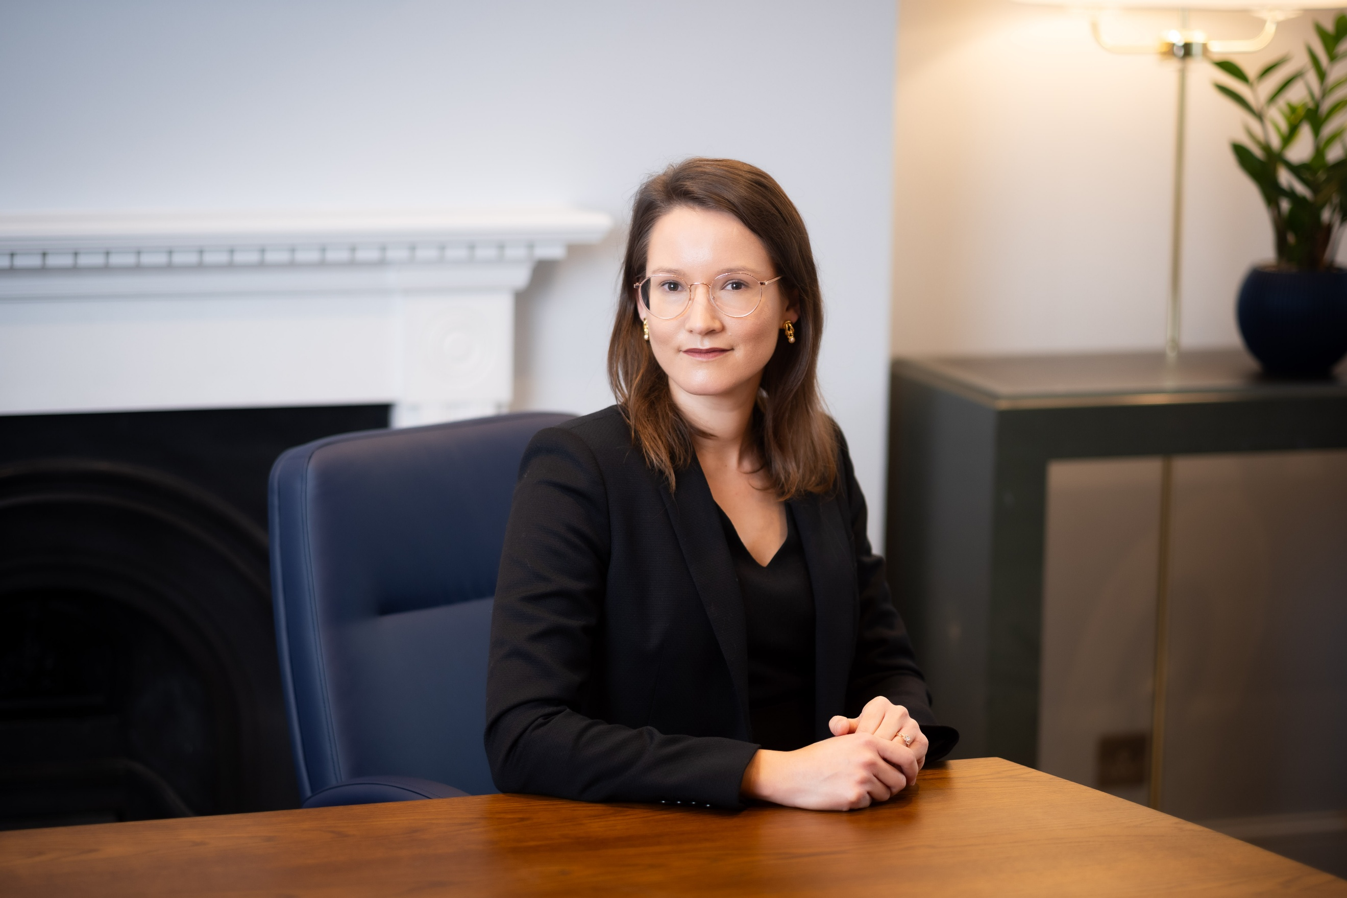

[JuniorsPMs@3vb.com](mailto:JuniorsPMs@3vb.com)

+44 (0)20 7831 8441

**Catherine Drummond**

Year of call:

Email:

**2022** (England and Wales)

**2024** (Belize)

**2013** (Queensland, Australia (Solicitor))

[**cdrummond@3vb.com**](mailto:cdrummond@3vb.com)

# Practice Overview

Catherine has a diverse practice spanning public international law, international arbitration, commercial law and public law. She joins Chambers from private practice where she acted as counsel in public international law and international arbitration.

She is described as having an “*extraordinary—almost mathematical—analytical ability*”, being a “*ferociously hard worker*” and a “*compelling*” advocate with “*excellent judgement*” who is “*destined for super-stardom*”. Clients also note her “*forensic understanding*” and “*encyclopaedic knowledge of all areas of public international law*”.

In respect of her public international law practice, Catherine is regularly instructed in cases before the International Court of Justice, the European Court of Human Rights, UN bodies and English courts on matters involving questions of public international law. She has extensive experience across a wide range of areas, including: State responsibility; the law of treaties; territorial and maritime disputes; immunities and privileges of States and international organisations; international human rights law including self-determination; international humanitarian law; international criminal law; climate change; international environmental law; the law of the sea; the law of international organisations; and the arms trade.

Catherine’s international arbitration practice spans investor-State and commercial arbitration. She has experience in matters conducted under ICSID, ICC, UNCITRAL and LCIA rules. She also has experience before the High Court, Court of Appeal and Supreme Court in matters relating to arbitration, including the enforcement of ICSID and New York Convention awards.

Having recently moved her practice to the bar, Catherine is looking forward to developing her English court practice. Her experience to date has involved matters before the High Court, Court of Appeal and Supreme Court relating to arbitration, State immunity and anti-suit injunctions. She has also acted as sole counsel before the County Court in consumer credit disputes.

# Expertise

**Arbitration and Related Court Applications**

* ***UK-Sandeel (EU v. UK)* (Inter-State Arbitration)**: counsel for the UK in its arbitration with the EU commenced under the Trade and Cooperation Agreement concerning prohibitions on the fishing of sandeel (led by Ben Juratowitch KC and Ned Westaway; and with Camille Boileau);
* ***Border Timbers Ltd & anor v. Republic of Zimbabwe* [2024] EWHC 58 (Comm); [2024] EWCA Civ 1257** (pending before the Supreme Court): counsel for the Border Timbers parties in a case concerning whether a State can resist registration of an ICSID award on grounds of State immunity (led by Christopher Harris KC; and with Dominic Kennelly);
* ***Star Hydro Power Limited v. National Transmission and Despatch Company Limited*** **[2024] EWHC 3258 (Comm)** (pending before the Court of Appeal) (led by Ricky Diwan KC Toby Landau KC): counsel for the National Transmission and Despatch Company Limited in resisting an application for anti-suit relief to injunct recognition and enforcement proceedings in a New York Convention State;
* ***LCIA arbitration***: counsel representing a State in an LCIA arbitration relating to a sovereign guarantee given for a hydroelectric power project;
* ***Four consolidated UNICTRAL arbitrations***: counsel representing an international inter-governmental organisation in four commercial arbitrations consolidated under the UNCITRAL Arbitration Rules concerning disputes relating to contracts for the provision of logistics services to field missions;
* ***ICC arbitration***: counsel representing two State-owned energy companies in an ICC arbitration concerning corruption in connection with the building of a power plant;
* ***ICC arbitration***: counsel representing an international energy company in an ICC arbitration concerning a long-term supply contract;
* ***ICC arbitration***: counsel representing a Fortune 500 company and related entities in an ICC arbitration against a Turkish company operating in the restaurant sector in relation to a post-M&A dispute;
* ***Bryn Services v. Latvia***: assisting counsel representing the Republic of Latvia in an ad hoc UNCITRAL arbitration under the Switzerland-Latvia BIT related to the dissolution of a Latvian bank;
* ***Investor-State advice***: merits reviews and advisory work in connecting with prospective investor-State arbitrations;
* ***Mustill & Boyd: Commercial and Investor-State Arbitration* (3rd ed, 2024)**:assisting Sam Wordsworth KC on three chapters on investor-State arbitration before English courts.

**Commercial Dispute Resolution**

* ***Star Hydro Power Limited v. National Transmission and Despatch Company Limited*** **[2024] EWHC 3258 (Comm)** (pending before the Court of Appeal) (led by Ricky Diwan KC Toby Landau KC): counsel for the National Transmission and Despatch Company Limited in resisting an application for anti-suit relief to injunct recognition and enforcement proceedings in a New York Convention State;
* ***Border Timbers Ltd & anor v. Republic of Zimbabwe* [2024] EWHC 58 (Comm); [2024] EWCA Civ 1257** (pending before the Supreme Court): counsel for the Border Timbers parties in a case concerning whether a State can resist registration of an ICSID award on grounds of State immunity (led by Christopher Harris KC; and with Dominic Kennelly);
* ***Argentum Exploration Ltd v. South Africa*** **[2024] UKSC 16**: assisted as a pupil in a case concerning South Africa’s claim to be immune in a salvage action in the first ever case to consider section 10(4)(a) of the State Immunity Act 1978 (led by Stephen Hofmeyr KC; and with Liisa Lahti and Cameron Miles).

**Public International Law**

**International Court of Justice:**

* ***Obligations of States in respect of Climate Change***: counsel for Antigua and Barbuda;
* ***Sovereignty over the Sapodilla Cayes (Belize* v. *Honduras)***: counsel for Belize (led by Sam Wordsworth KC, Ben Juratowitch KC, Mathias Forteau and Payam Akhavan; and with Naomi Hart, Camille Boileau and Justina Uriburu);
* ***Guatemala’s Territorial, Insular and Maritime Claim (Guatemala/Belize)***: counsel for Belize (led by Sam Wordsworth KC, Ben Juratowitch KC, Mathias Forteau and Jamie Trinidad KC; and with Amy Sander, Kate Parlett and Philippa Webb);
* ***Application of the Convention on the Prevention and Punishment of the Crime of Genocide in the Gaza Strip (South Africa* v. *Israel)***: counsel for Belize as an intervening State (led by Ben Juratowitch KC; and with Callista Harris);
* ***Obligations of Israel in relation to the Presence and Activities of the United Nations, Other International Organizations and Third States in and in relation to the Occupied Palestinian Territory***: advising a State on participating (led by Ben Juratowitch KC; and with Phillippa Webb and Callista Harris).
* ***Legal Consequences arising from the Policies and Practices of Israel in the Occupied Palestinian Territory, including East Jerusalem***: counsel for Belize (led by Ben Juratowitch KC; and with Phillippa Webb and Callista Harris);
* ***Allegations of Genocide under the Convention on the Prevention and Punishment of the Crime of Genocide (Ukraine* v. *Russian Federation)***: advising an intervening State;
* ***Legal Consequences of the Separation of the Chagos Archipelago from Mauritius in 1965***: counsel for Belize (led by Ben Juratowitch KC; and with Callista Harris);
* ***Obligation to Negotiate Access to the Pacific Ocean (Bolivia* v. *Chile)***: counsel for Chile (led by Sir Daniel Bethlehem KCMG KC, Sam Wordsworth KC, Jean-Marc Thouvenin, Harold Koh, Ben Juratowitch KC and Mónica Pinto; and with Kate Parlett, Daniel Müller, Alexa van der Meulen, Callista Harris and Yuri Mantilla).

**Inter-State Arbitration:**

* ***UK-Sandeel (EU v. UK)***: counsel for the UK in its arbitration with the EU commenced under the Trade and Cooperation Agreement concerning prohibitions on the fishing of sandeel (led by Ben Juratowitch KC and Ned Westaway; and with Camille Boileau).

**European Court of Human Rights:**

* ***An inter-State case*** concerning the protection of nationals as regards their right to a fair trial, freedom from ethnic discrimination, privacy and property rights;
* ***Slovenia v. Croatia***: counsel for Sloveniaconcerning the treatment of a State-owned Slovenian bank by the Croatian authorities (led by Ben Juratowitch KC; and with Daniel Müller);
* ***Semenya v. Switzerland***: assisting Can Yeginsu as a pupil on an intervention in this Grand Chamber case.

**English courts:**

* ***R (on the application of Al-Haq) v. Secretary of State for Business and Trade***: counsel for Al-Haq in challenging the UK Government’s decision not to suspend licenses for arms exports to Israel in the context of its conduct in Gaza. The grounds of challenged centred on compliance by the UK with its obligations under Common Article 1 to the Geneva Conventions, the obligation to prevent genocide, Articles 6-7 of the Arms Trade Treaty and the rules reflected in Articles 16 and 41 of the ILC’s Articles on State Responsibility (led by Phillippa Kaufmann KC, Raza Husain KC and Blinne Ní Ghrálaigh KC);
* ***Border Timbers Ltd & anor v. Republic of Zimbabwe* [2024] EWHC 58 (Comm); [2024] EWCA Civ 1257** (pending before the Supreme Court): counsel for the Border Timbers parties in a case concerning whether a State can resist registration of an ICSID award on grounds of State immunity (led by Christopher Harris KC; and with Dominic Kennelly);
* ***Argentum Exploration Ltd v. South Africa*** **[2024] UKSC 16**: assisted as a pupil in a case concerning South Africa’s claim to be immune in a salvage action in the first ever case to consider section 10(4)(a) of the State Immunity Act 1978 (led by Stephen Hofmeyr KC; and with Liisa Lahti and Cameron Miles).

**Other international courts and bodies:**

* ***The Situation in The State of Palestine* (International Criminal Court)**: counsel for Addameer Prisoner Support and Human Rights Association and victims represented by Addameer in respect of jurisdictional questions (the territorial scope of the Prosecutor’s jurisdiction; the Court’s jurisdiction over Israeli nationals) (led by Steven Powles KC, Blinne Ní Ghrálaigh KC and Jemima Stratford KC).
* ***The Prosecutor v. Bemba Gombo* (International Criminal Court)**: counsel for the REDRESS Trust in the filing of an amicus curiae brief concerning reparations for international crimes;
* ***The Prosecutor v. Ntaganda* (International Criminal Court)**: counsel for the REDRESS Trust in the filing of an amicus curiae brief concerning the Prosecutor’s characterization of the charges (the charging of rape and sexual slavery of torture);
* ***Complaint to the United Nations Human Rights Committee***: counsel for a human rights defender in a case against a central Asian State for violations of the International Covenant of Civil and Political Rights;
* ***Cases 003 and 004* (Extraordinary Chambers of the Courts of Cambodia)**: co-authoring an amicus curiae brief on the content of crimes against humanity under customary international law in the 1970s (with Professors Dapo Akande and Philippa Webb).

**Advisory work and training:**

* ***Climate change***: advising on the interrelationship between States’ obligations under the UNFCCC and Paris Agreement, and States’ obligations under other related rules of international law;
* ***Human rights***: advising on extraterritoriality under the African Charter on Human and People’s Rights;
* ***Arbitrary Detention***: advisor to the United Nations Working Group on Arbitrary Detention (2018-2022);
* ***Law of the Sea***: advising on the negotiations for an international legally binding instrument under the United Nations Convention on the Law of the Sea on the conservation and sustainable use of marine biological diversity of areas beyond national jurisdiction (BBNJ, now called the High Seas Treaty);
* ***Human rights***: advising the International Service for Human Rights (ISHR) on a range of public international law matters, including the obligations of the United Nations Human Rights Council, regimes for the protection of human rights defenders and the domestic implementation of international human rights law in an African State;
* ***Human rights***: advising an international non-governmental organisation on a range of public international law matters, including the use of strategic litigation to obtain compensation for human rights violations;
* ***Specific treaty regime***:advising Hapag-Lloyd AG on the public international law implications of its acquisition of United Arab Shipping Company S.A.G., a company established under a treaty and not incorporated in any domestic jurisdiction;
* ***Private rights and sovereignty disputes***: advising a number of international energy companies on their rights in respect of areas over which sovereignty is disputed;
* ***Specific treaty regime***:advising a non-governmental organisation on the extent to which a peace agreement concluding a non-international armed conflict gave rise to obligations of guarantee for States and international organisations that signed as ‘guarantors’ of the peace agreement;
* ***Arms Trade Treaty***: providing preparatory and real-time analysis and advice to participants during the first implementation conference for the Arms Trade Treaty (with a focus on risk assessment thresholds for serious violations of international humanitarian law and international human rights law, and related import, export, transit and trans-shipment obligations);
* ***Transboundary resource disputes***:assisting in the delivery of a capacity-building workshop for government officials on the resolution and management of transboundary resource disputes (with Durham University’s International Boundaries Research Unit ( UNGA side event, New York));
* ***International humanitarian law and international criminal law***:delivered training to the Australian Defence Forces on international humanitarian law and the domestic prosecution of international crimes (with the Australian Red Cross);
* ***International refugee law***: providing submissions to Australian Parliamentary inquiries into the legality under international law of Australia’s actions relating to refugees and asylum seekers.

**Public Law**

* ***R (on the application of Al-Haq) v. Secretary of State for Business and Trade***: counsel for Al-Haq in challenging the UK Government’s decision not to suspend licenses for arms exports to Israel in the context of its conduct in Gaza. The case raised issues of justiciability, foreign act of State, standard of review (tenability/correctness), the reception of customary international law rules into the common law, the risk of facilitating the commission of a crime under UK law, departure from policy, as well as consistency with the UK’s international law obligations under Common Article 1 to the Geneva Conventions, the obligation to prevent genocide, Articles 6-7 of the Arms Trade Treaty and the rules reflected in Articles 16 and 41 of the ILC’s Articles on State Responsibility (led by Phillippa Kaufmann KC, Raza Husain KC and Blinne Ní Ghrálaigh KC).

# Career

**Professional:**

* Barrister 2024-
* Pupil Barrister, 2023-2024
* Counsel in public international law and arbitration, 2018-2024
* Associate, Public international law and arbitration, Freshfields Bruckhaus Deringer (Paris), 2016-2018
* Consultant, Public international law, 2015-2016
* Associate, Public international law and arbitration, Freshfields Bruckhaus Deringer (Paris), 2014
* Judicial Associate, President McMurdo, Queensland Court of Appeal (Australia), 2013
* Intern, International Criminal Tribunal for Rwanda, Arusha, Tanzania, 2012

**Academic positions (alongside practice):**

* Teaching Assistant, LLM (Public International Law), University of Cambridge, 2019-2023
* Sessional Lecturer, Masters of International Law and Diplomacy (International Dispute Settlement), American University of Paris, 2016-2018
* Sessional Lecturer, Masters of Common and Comparative Law (International Dispute Settlement) University of Paris Descartes, 2017
* Sessional Lecturer and Tutor, Bachelor of Laws (Public International Law), University of Queensland, 2013, 2015
* Philip C. Jessup International Law Moot Coach, 2011-2015
* Research Assistant, UN Asia-Pacific Centre for the Responsibility to Protect, 2009-2012
* Research Assistant (Public International Law), University of Queensland, 2009-2012

**Other:**

* Cambridge International Law Journal, Editor-in-Chief, 2019-2020
* Cambridge International Law Journal, Managing Editor, 2018-2019
* Cambridge International Law Journal, Editor, 2014-2015
* Australian Red Cross, International Humanitarian Law Advisory Committee, 2013-2014
* Amnesty International, Human Rights in Law Group Convenor, Queensland, 2011-2012

**Education:**

* PhD, University of Cambridge (ongoing)
* LLM (First Class Honours), University of Cambridge, 2014-2015
* Hague Academy of International Law, 2013
* LLB (Honours), University of Queensland (Australia), 2006-2012
* BA (Peace and Conflict Studies / International Relations), University of Queensland (Australia), 2006-2012

### Awards:

* International Pro Bono Barrister of the Year 2025, Special Merit.
* Holland-Whittaker Scholarship, Trinity College, University of Cambridge, 2018-2022
* Whewell Prize in International Law, University of Cambridge, 2015
* William Charnley Prize (Hughes Hall), University of Cambridge, 2015
* General Sir John Monash Scholarship, 2014
* International Law Association (Australia) Brennan Prize in Public International Law, 2013
* University of Queensland (Australia) Pro Bono Centre Award, 2013
* Australian of the Year, Nominee, 2012
* Queensland Bar Association Margaret McMurdo Bursary, 2011
* University of Queensland (Australia) Law Society Medal for Most Outstanding Graduate, 2012
* Dean’s Commendations for Distinguished Academic Achievement, University of Queensland (Australia), 2007-2012